**Project 1**

Tittle

**Master Mind**

Course

**CSC-7**

Section

**42645**

Due Date

**April 19, 2017**

Author

**Sili Guo**

1. **Introduction**

Master Mind is a tradition American game which has a high requirement of logic thinking and basic knowledge for algorithm. During the game, player are asked to guess the color and position of a set of balls that listed in random order. There will be hints for the correct color numbers and correct color and position numbers each turn; and players can use this hint to make further guess.

During each turn, players should use logic and the previous result to eliminate the wrong color and approach the range of correct colors. Sometimes, it is a good strategy to first get all colors correct, then consider about the positions.

Also, when guessing each time, trying to put balls in different position can help you to shorten the steps you need to find out the correct position of each ball.

Players who guess all balls in correct color and correct positions will win the game. Some Master Mind game has a restriction of turn numbers to get correct, others just record the turns players have spent.

**II. Game Rules**

**A. Basic Rules**

1. Start a new game.
2. Choose game mode.
3. Make guesses and look at hints.
4. Check turn numbers you have used to solve the game.

**B. Game Mode**

1. The number of balls.
   * 4 balls
   * 6 balls
   * 8 balls
2. Duplicated
   * Allow duplicated
   * Don’t allow duplicated

**C. Win**

1. Who has all positions correct win the game.
2. )If you want to compete with friends, compare the turn numbers both used to win the game!

**III. Summary**

|  |  |
| --- | --- |
| **Total Line of Code** | **219** |
| **Comment Line** | - |
| **Variable** | 13 |
| **Function** | 1 |

Basically, this Master Mind game allows player to have choices of how many balls for guessing and if duplicated is allowed. The program is build on the combination of switch case and loop. I used dynamic array to utilize the change between the number of balls. To make the process fluent, I use the windows clear command to refresh the new pages.

To help player check the previous guess, I keep the history in each turn and player can move up to see it. If player likes to compete with other friends, record the turn numbers for solving the problem is a helpful way to do it.

**IV. Description**

**A. Flowcharts**

Main: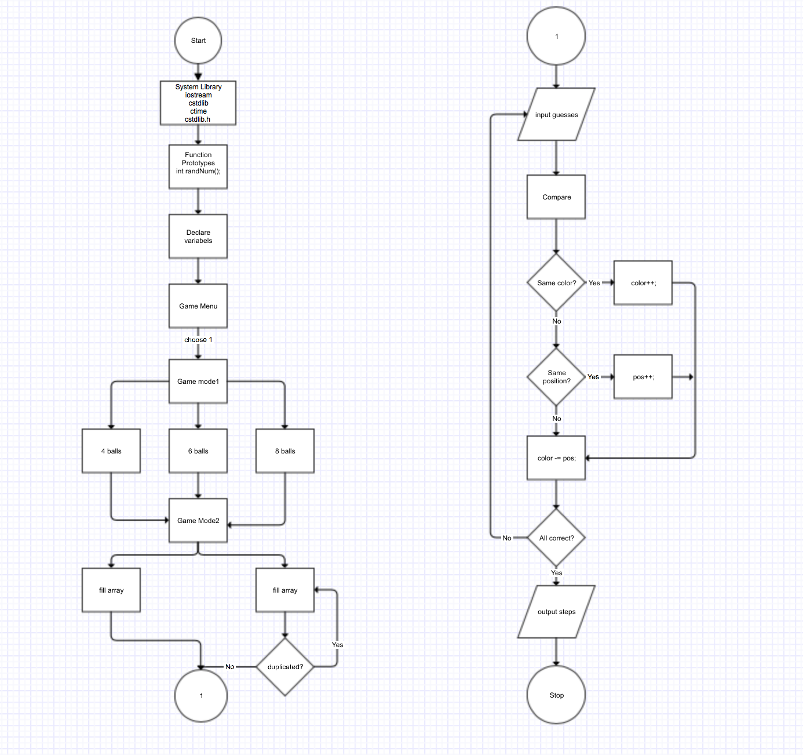

**B. Process**

First, choose game menu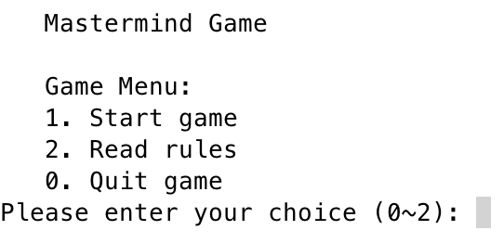

Suggest read game rules before playing game.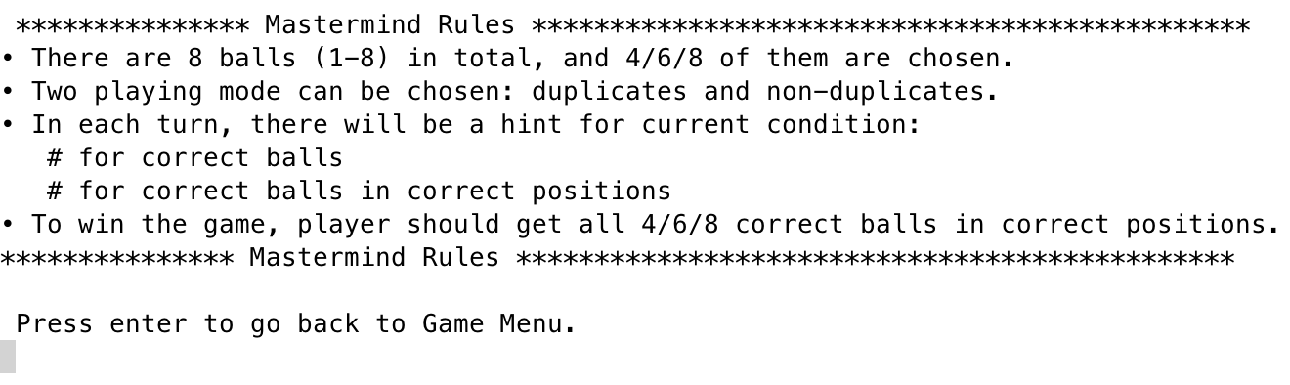

Start game.

Choose number of balls.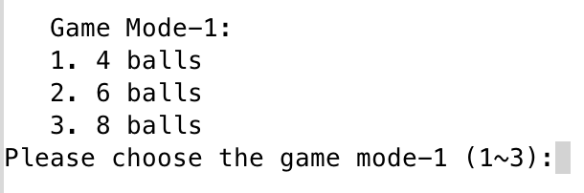

Choose duplicated allowance.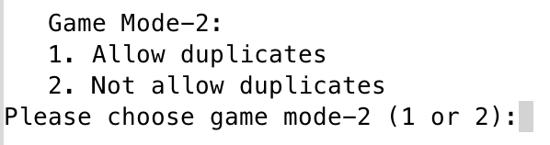

Start turn #1, enter your first 4/6/8 guesses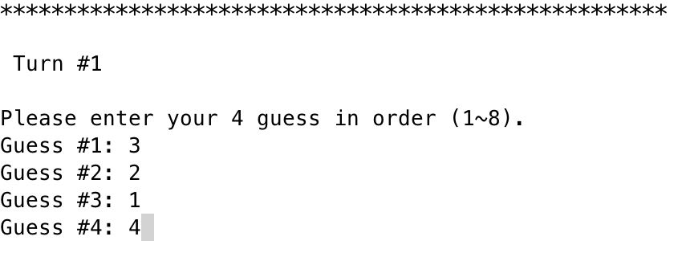

Program automatically show the hints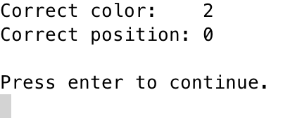

repeat until you get all 4 balls in correct color and correct positions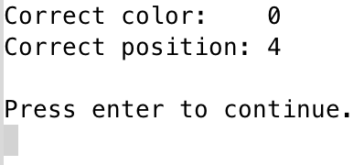

Check how many steps you solve the game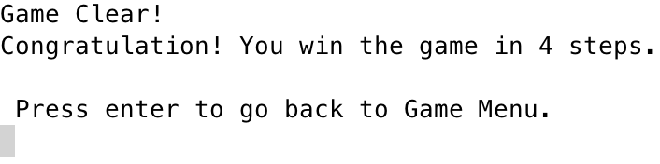

press 0 to quit the game

**VI. Code**

/*

* File: main.cpp

* Author: Sili Guo

* Created on April 9, 2017

* Purpose: Mastermind Game

*/

//System Libraries

#include <iostream>

#include <cstdlib>

#include <ctime>

#include <stdlib.h>

using namespace std;

//User Libraries

//Global Constants

//Function Prototypes

int randNum();

//Execution Begins here!

int main(int argc, char** argv) {

//Random number seed

srand(static_cast<unsigned int> (time(0)));

//Declare Variables

//Constants

const int TOTAL = 8;

const int SELCT = 4;

int color[TOTAL] = {1, 2, 3, 4, 5, 6, 7, 8}; //8 colors

int *select; //Select 4 colors

int *guess; //Player's guess

int *copy; //Copy of selection

int start; //Game menu choice

int choice; //Game mode choice

int balls; //How many balls for guessing

int turn; //Game turns

int num; //# of balls in correct color

int pos; //# of balls in correct color and in correct position

char enter; //Clear screen signal

bool same; //Check duplicates

bool win; //Mark for win

//Game menu

do {

system("clear");

turn = 1;

win = false;

cout << endl << " Mastermind Game" << endl << endl;

cout << " Game Menu:" << endl;

cout << " 1. Start game" << endl;

cout << " 2. Read rules" << endl;

cout << " 0. Quit game" << endl;

cout << "Please enter your choice (0~2): ";

cin >> start;

if (start != 1 && start != 2) {

system("clear");

cout << "You quit the game." << endl;

break;

}

switch (start) {

case 1:

system("clear");

cout << "\n Game Mode-1:" << endl;

cout << " 1. 4 balls" << endl;

cout << " 2. 6 balls" << endl;

cout << " 3. 8 balls" << endl;

cout << "Please choose the game mode-1 (1~3):";

cin >> balls;

switch (balls) {

case 1:

balls = 4;

break;

case 2:

balls = 6;

break;

case 3:

balls = 8;

break;

}

select = new int[balls];

guess = new int[balls];

copy = new int[balls];

system("clear");

cout << "\n Game Mode-2:" << endl;

cout << " 1. Allow duplicates" << endl;

cout << " 2. Not allow duplicates" << endl;

cout << "Please choose game mode-2 (1 or 2):";

cin >> choice;

switch (choice) {

case 1://Allow duplicates

for (int i = 0; i < balls; i++)

//Randomly create # 1~8

select[i] = randNum();

// //For test

// for (int i = 0; i < balls; i++)

// cout << select[i] << " ";

// break;

default://Not allow duplicates

for (int i = 0; i < balls; i++) {

do {

//Randomly create # 1~8

select[i] = rand() % 8 + 1;

// //For test

// cout << "test " << i << ": " << select[i] << endl;

//Check for duplicates

if (i > 0) {

same = false;

for (int j = i - 1; j >= 0; j--) {

if (select[i] == select[j]) {

same = true;

break;

}

}

}

} while (same); //Loop when duplicates

}

}//End of swich case

cout << endl;

//Ask player for guess

system("clear");

// //For test

// for (int i = 0; i < balls; i++)

// cout << select[i] << " ";

do {

num = 0;

pos = 0;

cout << "****************************************************" << endl;

cout << "\n Turn #" << turn << endl << endl;

cout << "Please enter your 4 guess in order (1~8)." << endl;

for (int i = 0; i < balls; i++) {

do {

cout << "Guess #" << i + 1 << ": ";

cin >> guess[i];

} while (guess[i] < 1 || guess[i] > 8);

}

//Copy the select array to enable for edit

for (int i = 0; i < balls; i++)

copy[i] = select[i];

//First check correct position

for (int i = 0; i < balls; i++) {

if (guess[i] == copy[i]) {

copy[i] = 0;

guess[i] = 9;

pos++;

}

}

//Then check for correct color

for (int i = 0; i < balls; i++) {

for (int j = 0; j < balls; j++) {

if (j != i) {

if (guess[i] == copy[j]) {

num++;

copy[j] = 0;

break;

}

}

}

}

cout << "\nCorrect color: " << num << endl;

cout << "Correct position: " << pos << endl << endl;

cout << "Press enter to continue." << endl;

cin.ignore();

do {

enter = getchar();

} while (enter != '\n');

//Check for win

if (pos == 4) win = true;

//Turns plus 1

turn++;

} while (!win && enter == '\n');

system("clear");

cout << "Game Clear!" << endl;

cout << "Congratulation! You win the game in " << turn - 1 << " steps." << endl;

break;

case 2:

system("clear");

//Output rules and menu

cout << "\n *************** Mastermind Rules **********************************************" << endl;

cout << "• There are 8 balls (1-8) in total, and 4/6/8 of them are chosen." << endl;

cout << "• Two playing mode can be chosen: duplicates and non-duplicates." << endl;

cout << "• In each turn, there will be a hint for current condition: " << endl;

cout << " # for correct balls" << endl;

cout << " # for correct balls in correct positions" << endl;

cout << "• To win the game, player should get all 4/6/8 correct balls in correct positions." << endl;

cout << "*************** Mastermind Rules **********************************************" << endl;

break;

}//End of switch case

cout << "\n Press enter to go back to Game Menu." << endl;

if (start == 2)

cin.ignore();

do {

enter = getchar();

} while (enter != '\n');

} while (enter == '\n');

//Exit Stage right!

delete [] select;

delete [] guess;

delete [] copy;

return 0;

}

int randNum() {

return rand() % 8 + 1;

}